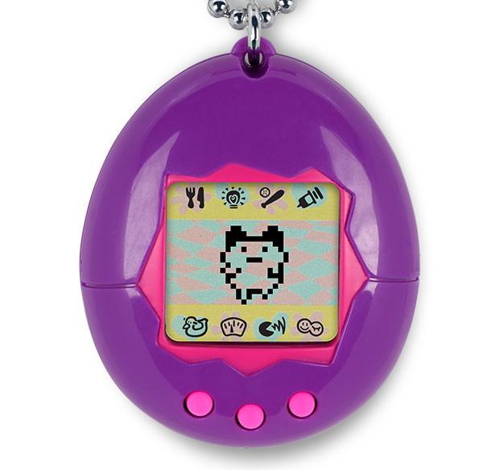**Tamagotchi**

Pros

Simple interface

-16x32 dot-matrix screen [Cheap to manufacture and makes crisp lines]

-cute animations

-Only 3 buttons

Small form factor (Easy to carry around)

-Keychain connector, Everyone has keys so everyone can carry one if they want

Simple physical appearance

-Simple single coloured plastic shell

-Shell is basically egg shaped, not a lot of moulding needed

Cons

Overly simplified gameplay

-Care needs are few and easy to care for

-only 3 buttons the user can push

-only 1-2 minigames [varies per iteration of the device]

Simple interface

-Screen is low res, meaning the animations are limited to what is achievable on a 16x32 DM screen.

-animations are very simple as a result.

Emotional Engagement

The life cycle of each pet goes through stages [baby, child, teen and adult] the game ends when the pet dies ,whether through neglect or old age, and hasn’t produced an offspring. The player initially starts of caring for the infant pet, they grow attached as the pet grows. Suddenly their invested in keeping a piece of code happy, as invested as they would be in keeping an actual flesh pet alive.

If the pet dies before reaching old age this is solely the players fault, the player could have saved their pet if they’d tried. This failure state introduced a base time investment be made to play, it wasn’t something you could put on a shelf and play once a week, the pets required care and could die in roughly half a day if left unattended.

This caused the pets to be banned in schools as children (target demographic) would take the pets with them and give them care during lessons, if they didn’t the pet could die while they were absent. This caused an issue for the schools who banned them as they would interfere with classes. Perhaps the pets were too emotionally engaging? If children were so engaged that they brought them to school and got them banned, which in turn would mean that many pets would die as a result of not receiving care, would this attribute to lower sales? Perhaps the care needs should be lessened at key times of the day eg, 9am – 3pm (the typical school times)